1)Create a Simple Pod Using YAML Task: Write a YAML file to create a Pod named firstpod with an nginx container. Verify the Pod creation using kubectl get pods and check the logs of the container using kubectl logs firstpod.

Step 1: Create YAML File
Create a file called firstpod.yaml

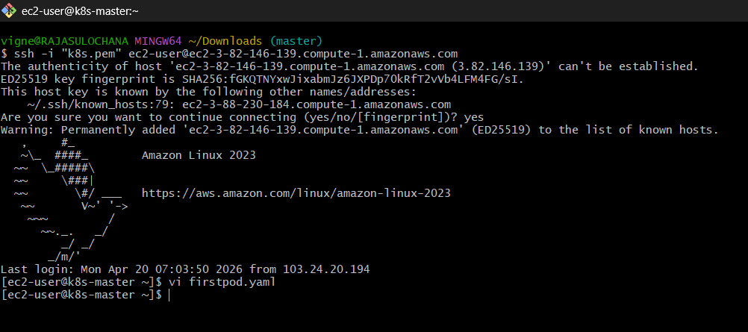

vi firstpod.yaml

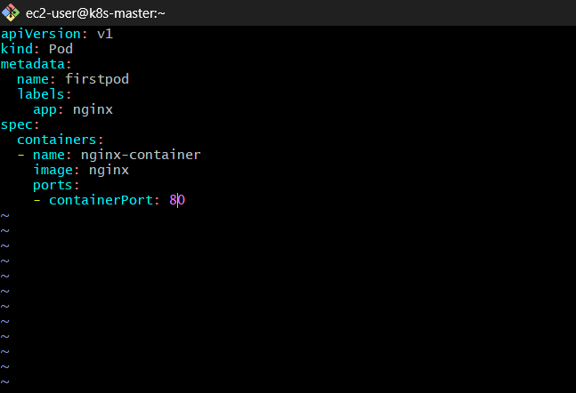
Now paste this YAML:
apiVersion: v1
kind: Pod
metadata:
name: firstpod
labels:
app: nginx
spec:
containers:
- name: nginx-container
image: nginx
ports:
- containerPort: 80

Save & exit:
- Press ESC
- Type :wq
- Hit Enter
Step 2: Create Pod in Kubernetes
Run this command:
kubectl apply -f firstpod.yaml

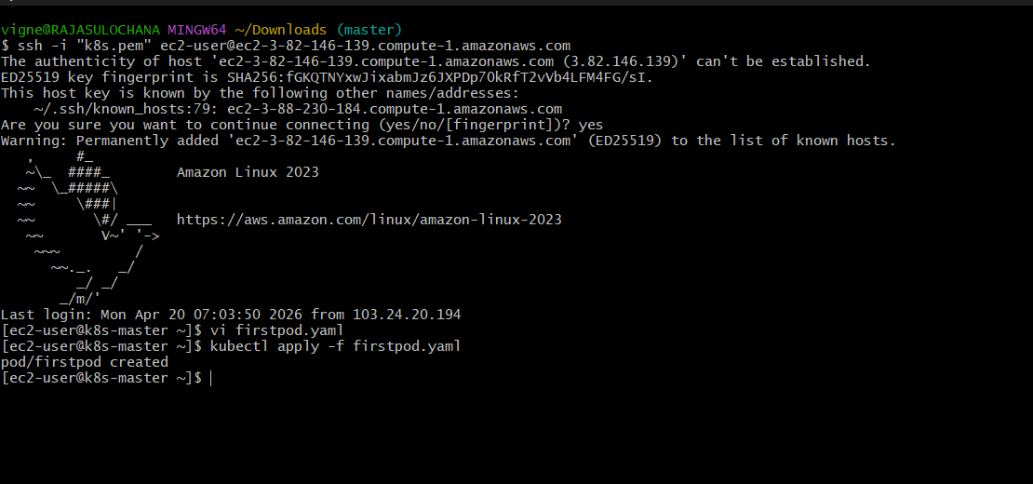
Output should be like:
pod/firstpod created

Step 3: Verify Pod Creation
Check pods:
kubectl get pods

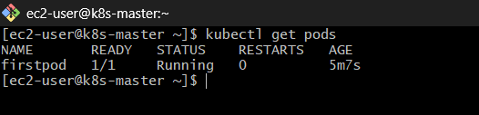
Example output:
NAME READY STATUS RESTARTS AGE
firstpod 1/1 Running 0 10s
If status is ContainerCreating, wait few seconds and run again.

Step 4: Get Detailed Info (Optional but Important)
kubectl describe pod firstpod

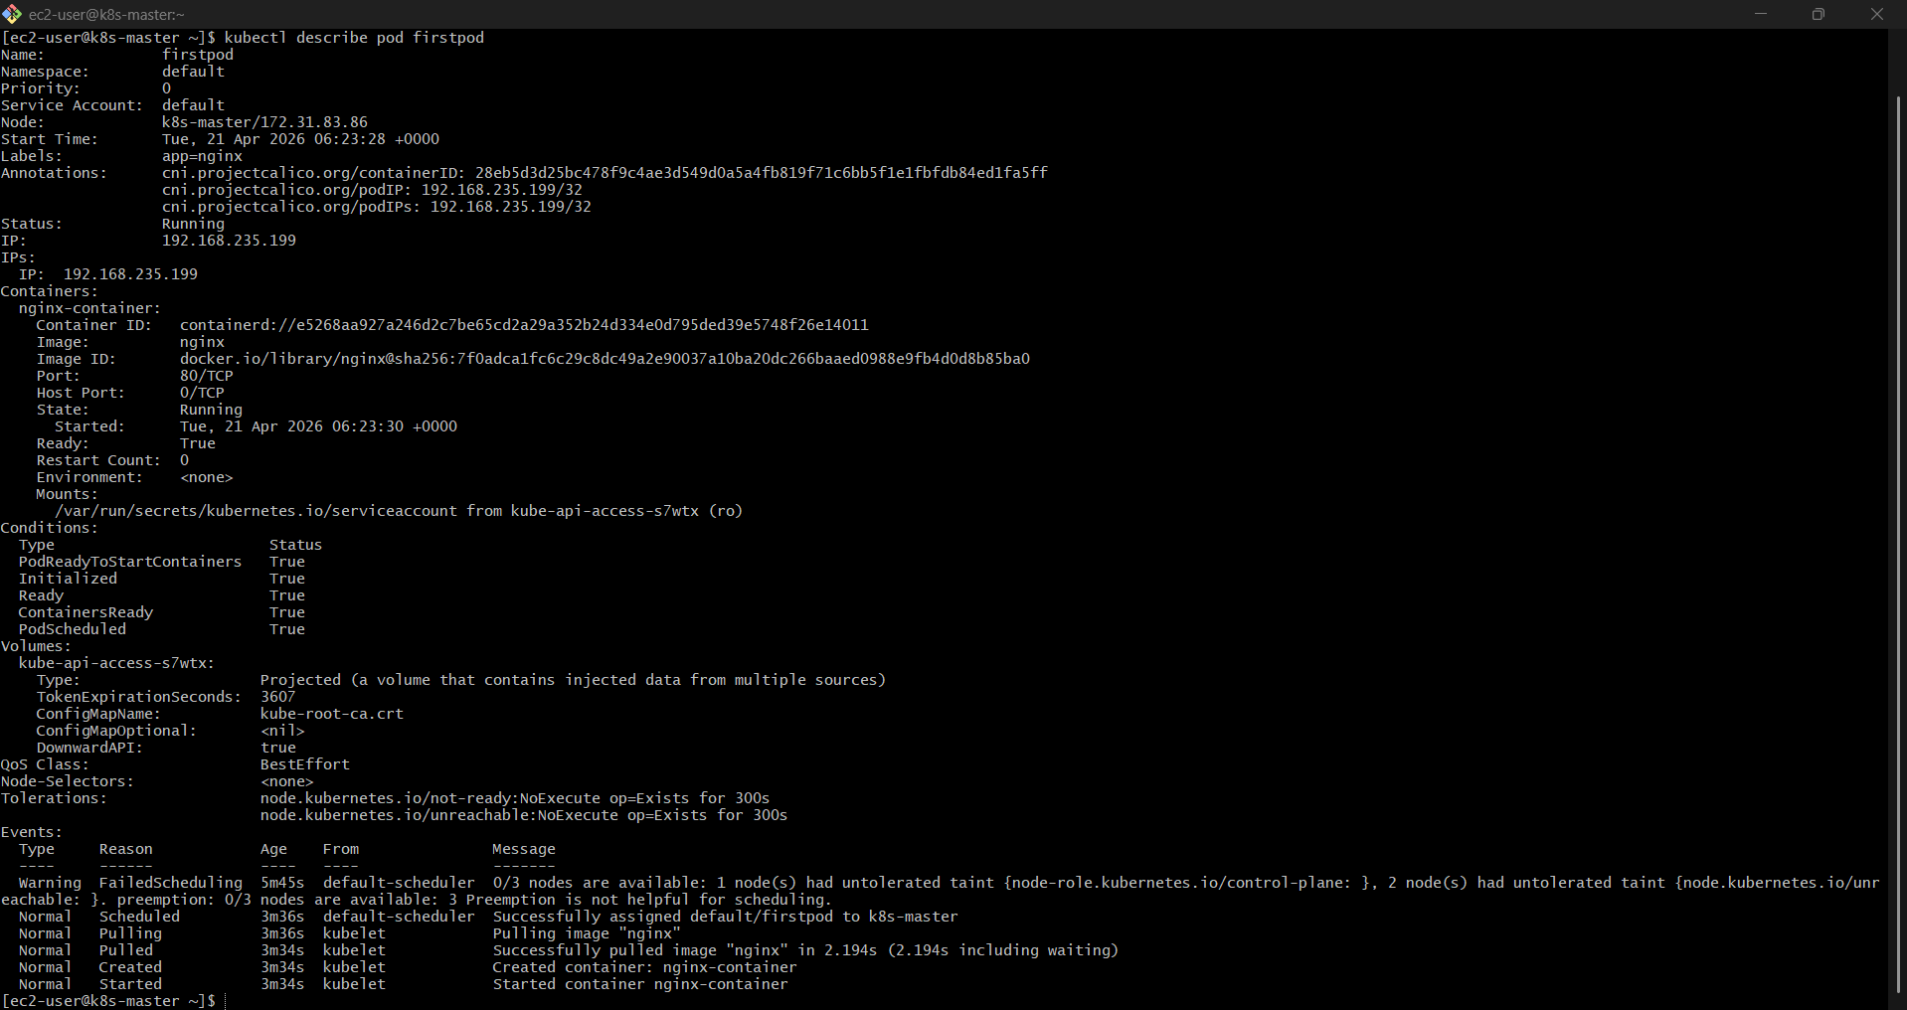

This shows:
- Events
- Image pulled
- Node info
- Errors (if any)

Step 5: Check Logs of Pod
kubectl logs firstpod

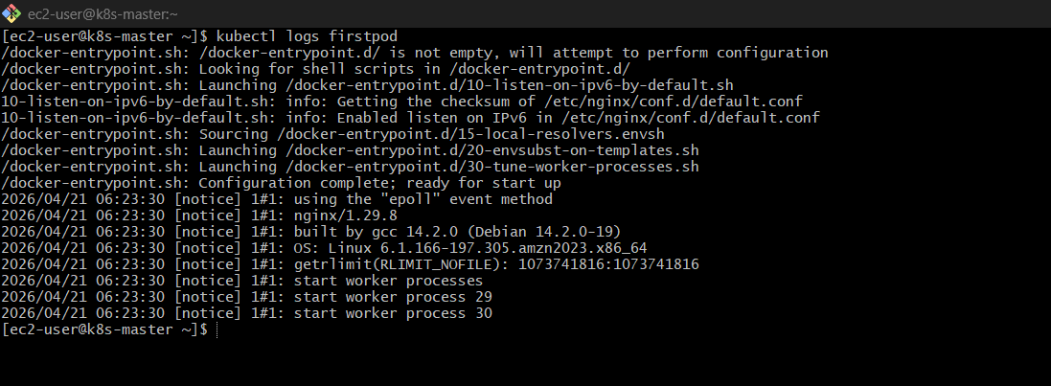

For nginx, logs will show:
- Access logs (if traffic hits)
- Startup messages

Step 6: (Optional) Access Pod
Run:
kubectl port-forward firstpod 8080:80

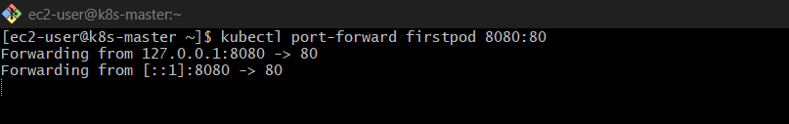
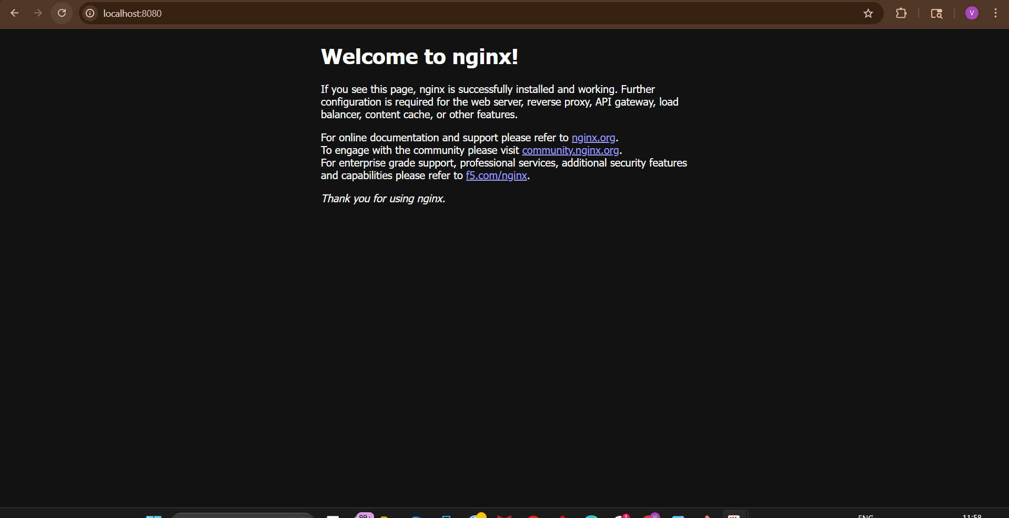
Now open browser:
http://localhost:8080
You’ll see NGINX welcome page

Common Errors
❌ If you get:
connection refused
Kubernetes cluster not running
✔ Fix: minikube start

❌ If image not pulling:
ImagePullBackOff
Check internet or image name

Final Flow
- Create YAML
- Apply YAML → kubectl apply -f
- Verify → kubectl get pods
- Debug → kubectl describe pod
- Logs → kubectl logs firstpod

2)Set Environment Variables in a Pod Task: Modify the YAML file to include environment variables myname: sabair and City: Hyderabad. Deploy the Pod and use kubectl exec <pod_name> -- env to check if the environment variables are set properly.

Step 1: Create YAML with Environment Variables
Open your file:
vi firstpod.yaml

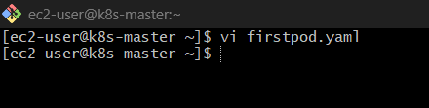

Replace with this updated YAML:

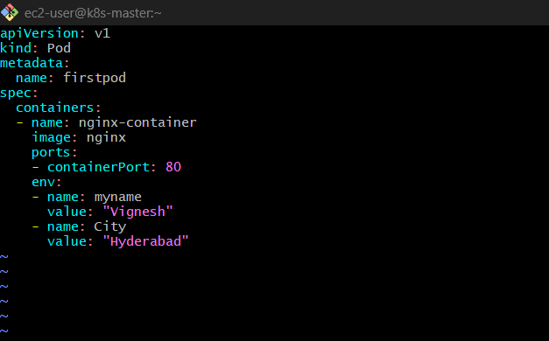

apiVersion: v1
kind: Pod
metadata:
name: firstpod
spec:
containers:
- name: nginx-container
image: nginx
ports:
- containerPort: 80
env:
- name: myname
value: "sabair"
- name: City
value: "Hyderabad"
Save:
- Press ESC
- Type :wq

Step 2: Delete Old Pod (IMPORTANT)
Since Pod already exists, delete it:
kubectl delete pod firstpod

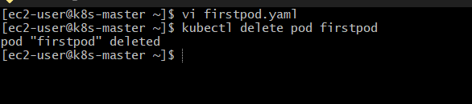
Wait until it is deleted

Step 3: Create New Pod
kubectl apply -f firstpod.yaml

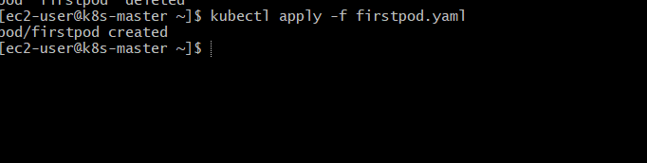

Step 4: Verify Pod is Running
kubectl get pods
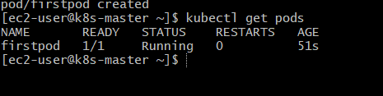
Wait until:
firstpod 1/1 Running

Step 5: Check Environment Variables Inside Pod
Run:
kubectl exec firstpod – env

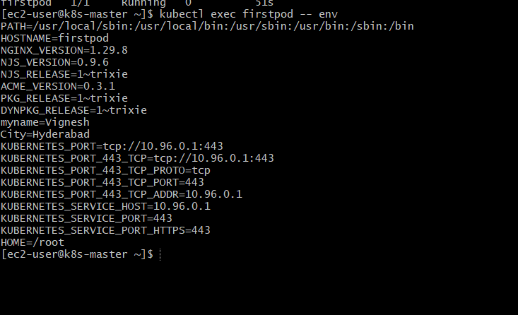
Output will contain many variables, look for:
myname=Vignesh
City=Hyderabad

Step 6: (Optional Filter Output)
To see only your variables:
kubectl exec firstpod -- env | grep -i name
kubectl exec firstpod -- env | grep -i city
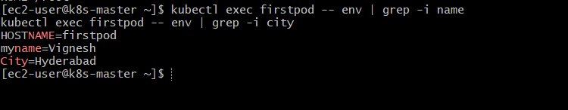

Common Errors
❌ Pod still Pending
Fix cluster issue first (node/CNI)

❌ Exec error:
error: unable to upgrade connection
Try:
kubectl exec -it firstpod -- /bin/bash
Then inside container:
env

Final Flow
- Add env: in YAML
- Delete old pod
- Apply YAML
- Check → kubectl get pods
- Verify → kubectl exec firstpod -- env

3) Deploy a Pod with Commands (Args) in YAML Task: Modify the YAML file to add args that instruct the container to sleep for 50 seconds. Deploy the Pod and use kubectl describe pod to verify the args are correctly passed to the container.

Step 1: Create / Modify YAML File
Open file:
vi sleep-pod.yaml

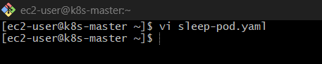

Paste this:
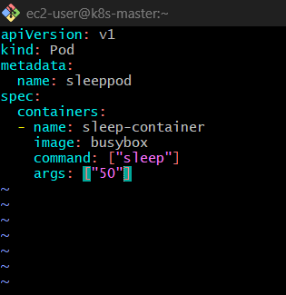
apiVersion: v1
kind: Pod
metadata:
name: sleeppod
spec:
containers:
- name: sleep-container
image: busybox
command: ["sleep"]
args: ["50"]

Important Concept
- command → ENTRYPOINT
- args → CMD
This means:
sleep 50

Step 2: Apply YAML

kubectl apply -f sleep-pod.yaml

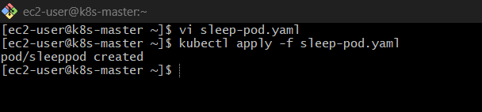

Step 3: Verify Pod Status
kubectl get pods

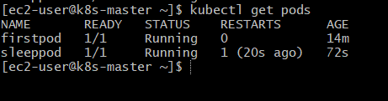
You’ll see:
sleeppod 1/1 Running 0 few seconds
After 50 seconds:
Completed

Step 4: Describe Pod (MAIN VERIFICATION)
kubectl describe pod sleeppod
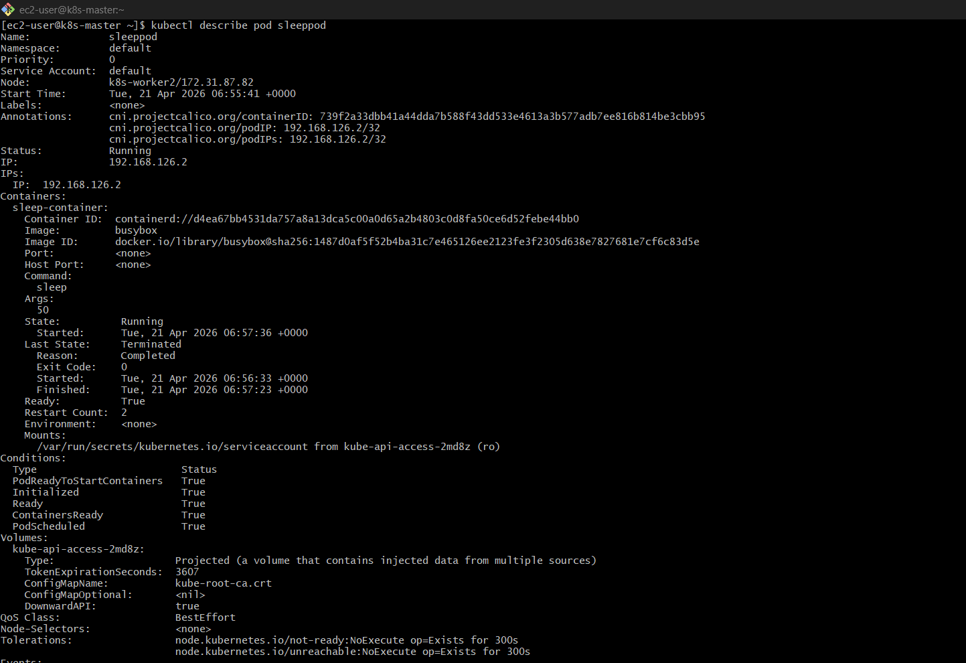
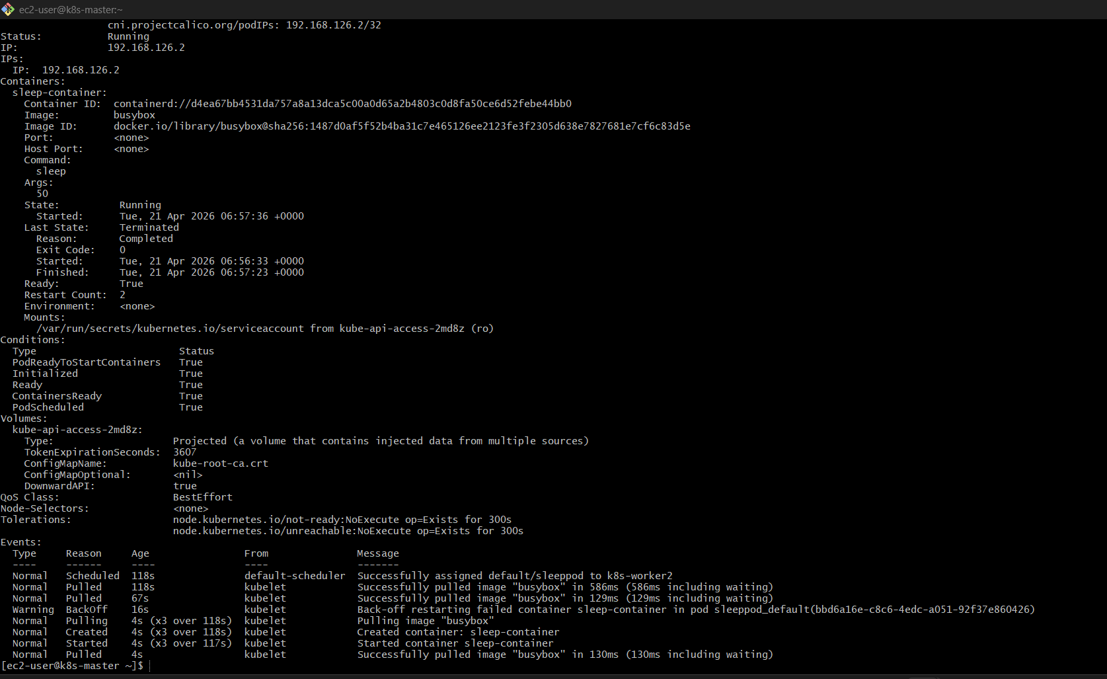

Look for this section:
Containers:
sleep-container:
Image: busybox
Command:
sleep
Args:
50

✅ This confirms args are passed correctly

Step 5: (Optional) Check Logs
kubectl logs sleeppod

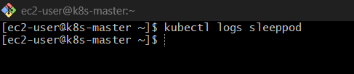
Busybox sleep → no output (normal)

Important Behavior
After 50 sec:
- Pod will STOP automatically
- Status = Completed
Check again:
kubectl get pods

Common Mistakes
❌ Using nginx with sleep
nginx won’t respect sleep → use busybox

❌ Missing command
args: ["50"]
This won’t work alone

Final Quick Flow
- Create YAML with command + args
- Apply → kubectl apply -f
- Verify → kubectl get pods
- Confirm → kubectl describe pod

4) Create a Pod with Two Containers Task: Create a YAML file to define a Pod with two nginx containers inside. Use kubectl exec to access both containers and verify that both containers can communicate through the same network (e.g., using telnet between them).

Step 1: Create YAML for Two Containers Pod
Open file:
vi twocontainer-pod.yaml

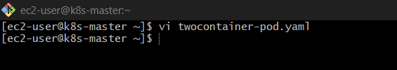
Paste this:
apiVersion: v1
kind: Pod
metadata:
name: twonginx
spec:
containers:
- name: nginx1
image: nginx
ports:
- containerPort: 80

- name: nginx2
image: nginx
ports:
- containerPort: 8080
command: ["/bin/sh"]
args: ["-c", "sed -i 's/80/8080/g' /etc/nginx/conf.d/default.conf && nginx -g 'daemon off;'"]

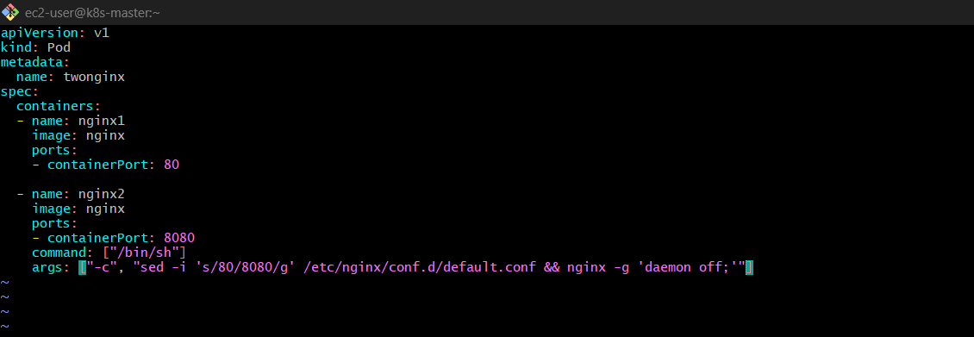
Save:
- ESC → :wq

Step 2: Deploy the Pod
kubectl apply -f twocontainer-pod.yaml

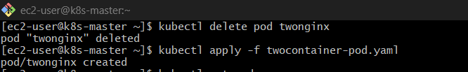

Step 3: Verify Pod
kubectl get pods

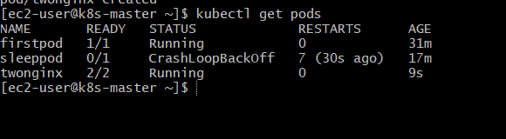

Expected:
twonginx 2/2 Running
2/2 = both containers running

Step 4: Exec into First Container
kubectl exec -it twonginx -c nginx1 -- /bin/bash

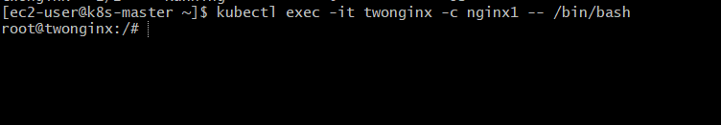
Inside container, run:
apt update
apt install -y telnet

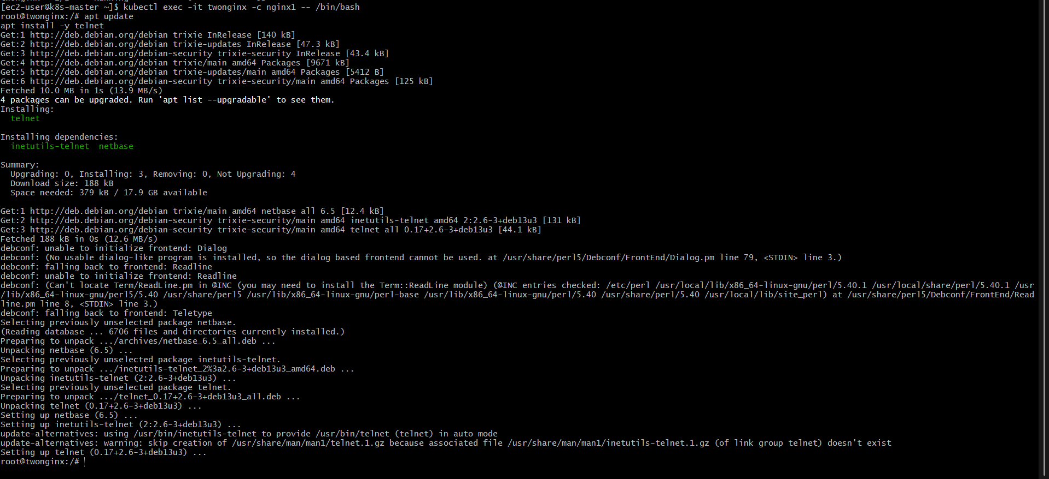

Step 5: Test Communication
Inside nginx1 container:
telnet localhost 80
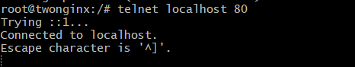
You should see:
Connected to localhost

CORE CONCEPT
In same Pod:
- Containers share same network namespace
- Same IP address
- Communicate using localhost
That’s why:
nginx1 → nginx2 = localhost:80

Step 6: Verify from Second Container (Optional)
Exit first container:
exit
Now enter second:
kubectl exec -it twonginx -c nginx2 -- /bin/bash

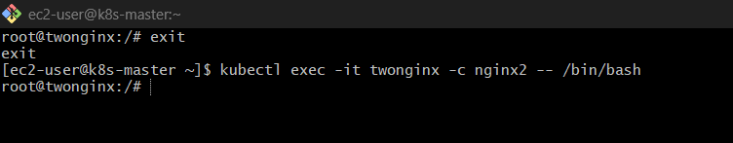
Then:
apt update
apt install -y telnet
telnet localhost 80
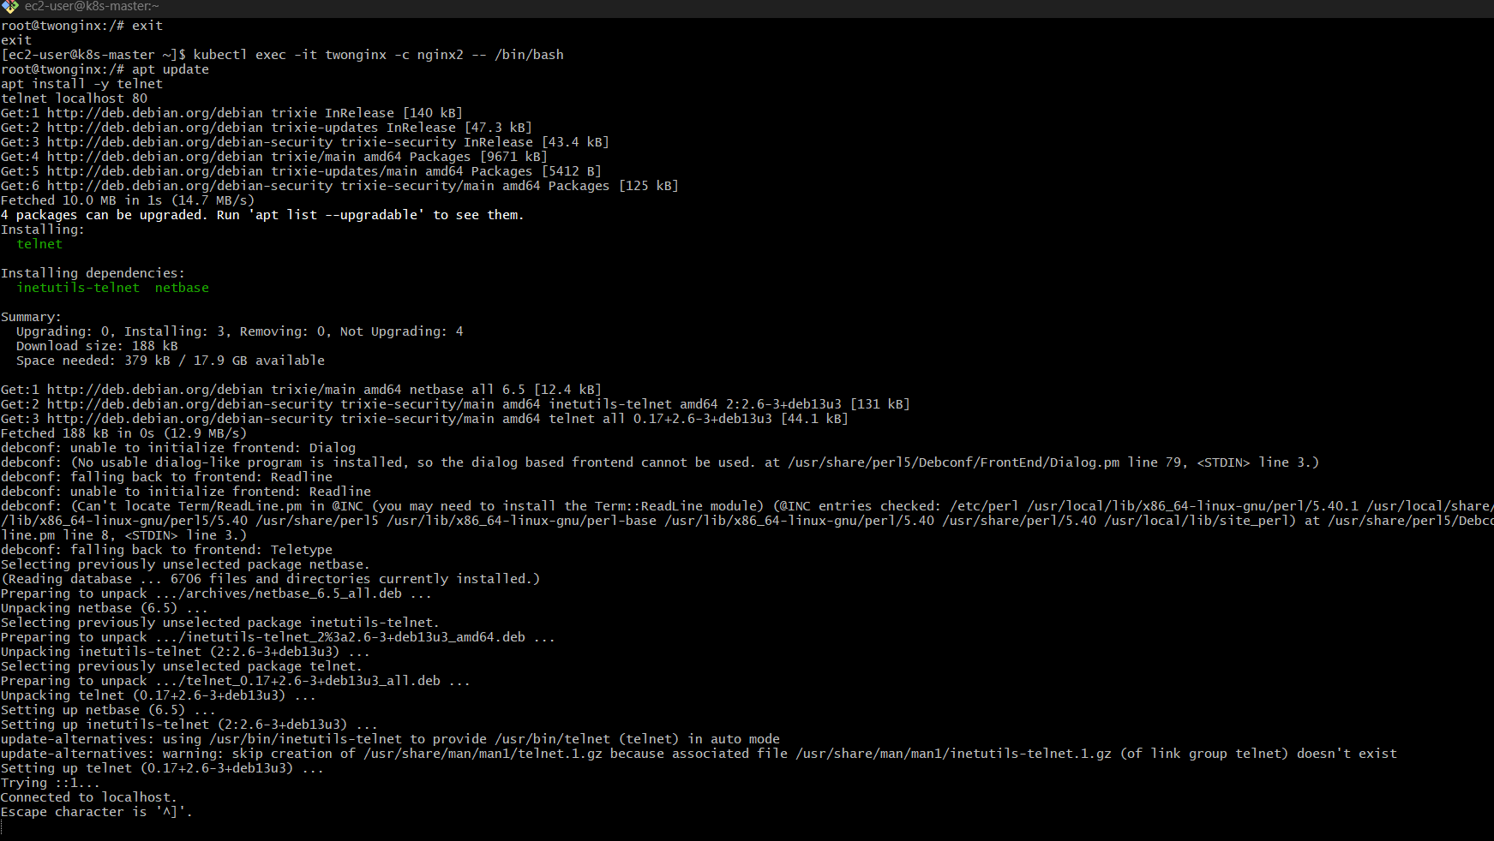

Important Notes
❌ If telnet not found
Use alternative:
curl localhost

❌ If bash not found
Use:
/bin/sh

Final Understanding
Same Pod = Same:
- IP
- Network
- Port space
Different Pods = Need Service

• Create YAML with 2 containers
• Apply YAML
• Exec into container (-c <name>)
• Test → telnet localhost 80

5) Set Up an Init Container in a Pod Task: Modify the YAML to include an init container that sleeps for 30 seconds before the main containers start. Verify the init container's execution using kubectl describe pod and check the logs to confirm its completion.

Step 1: Create YAML with Init Container
Open file:
vi init-pod.yaml

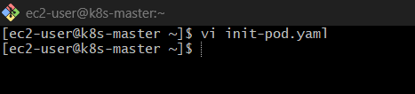
Paste this:
apiVersion: v1
kind: Pod
metadata:
name: initpod
spec:
initContainers:
- name: init-sleep
image: busybox
command: ["sh", "-c", "sleep 30"]
containers:
- name: nginx1
image: nginx
ports:
- containerPort: 80
- name: nginx2
image: nginx
ports:
- containerPort: 8080
command: ["/bin/sh"]
args: ["-c", "sed -i 's/80/8080/g' /etc/nginx/conf.d/default.conf && nginx -g 'daemon off;'"]

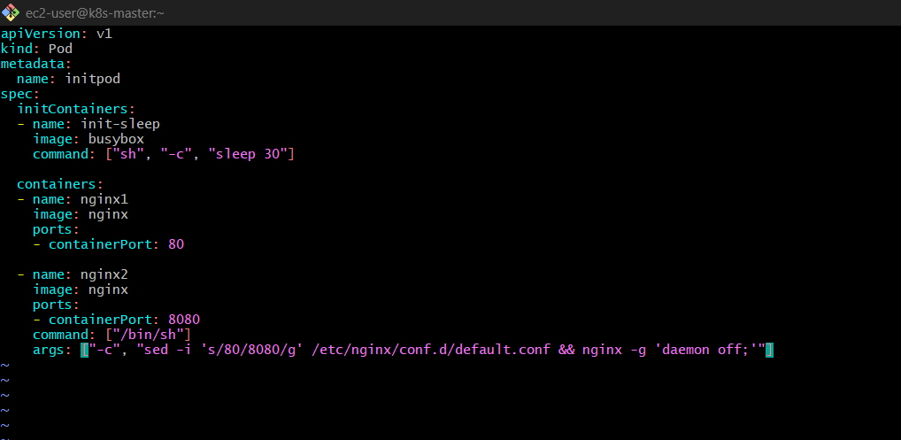
Save:
- ESC → :wq

Concept
initContainers:
- Run before main containers
- Must complete successfully
- Then only main containers start
Flow:
Init Container → Completed → Main Containers Start

Step 2: Deploy Pod
kubectl apply -f init-pod.yaml

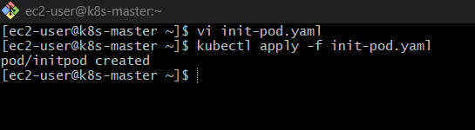

Step 3: Watch Pod Status
kubectl get pods

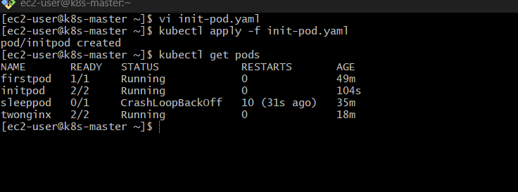
Initially:
initpod 0/2 Init:0/1
After 30 sec:
initpod 2/2 Running

Step 4: Verify Init Container (IMPORTANT)
kubectl describe pod initpod

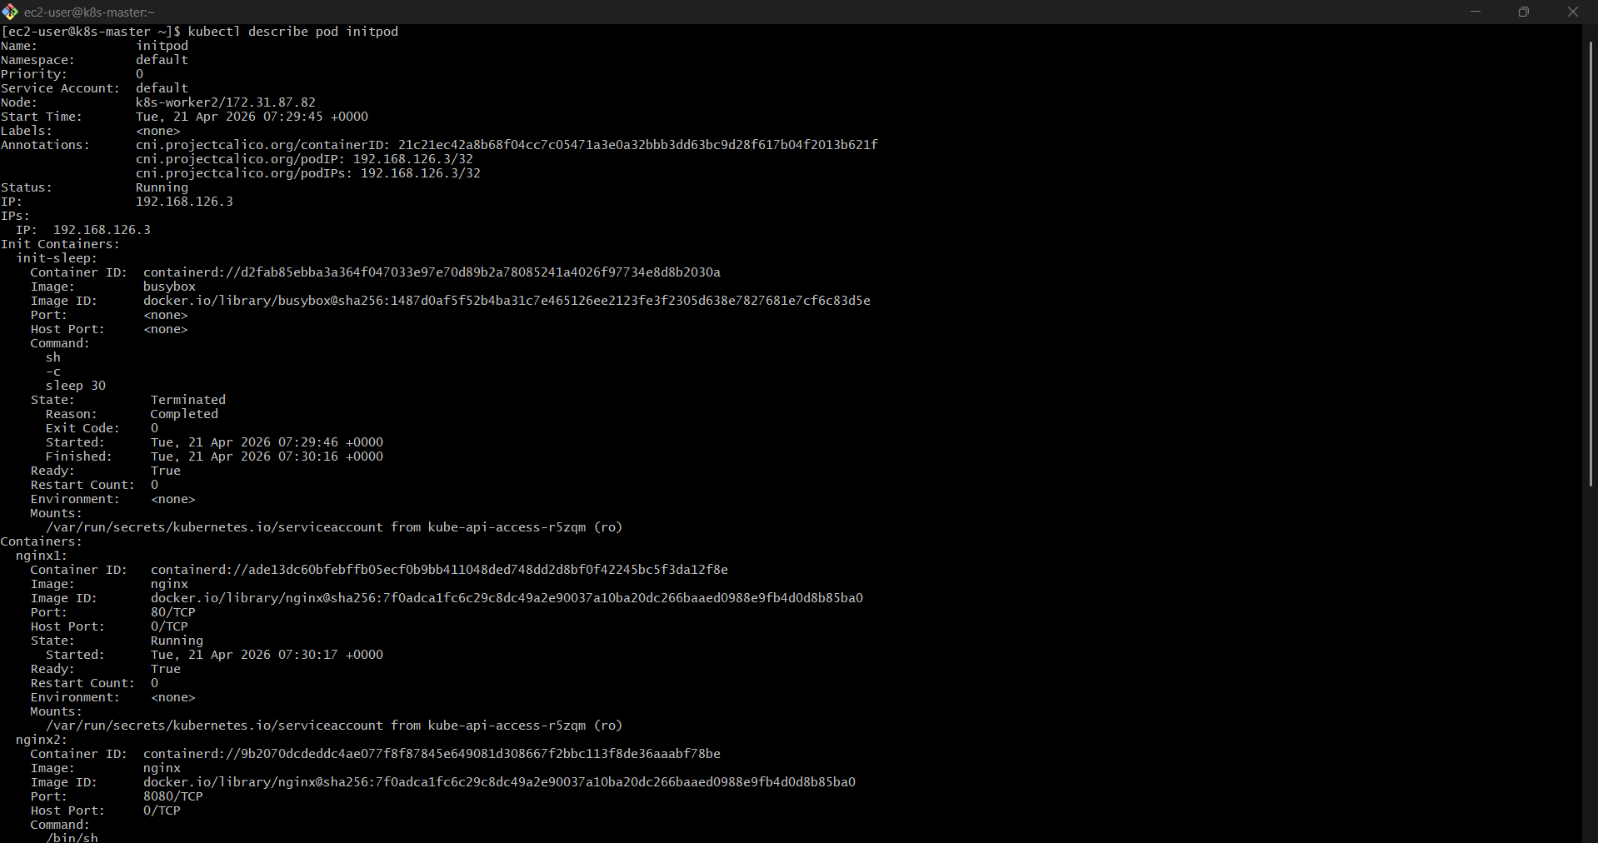
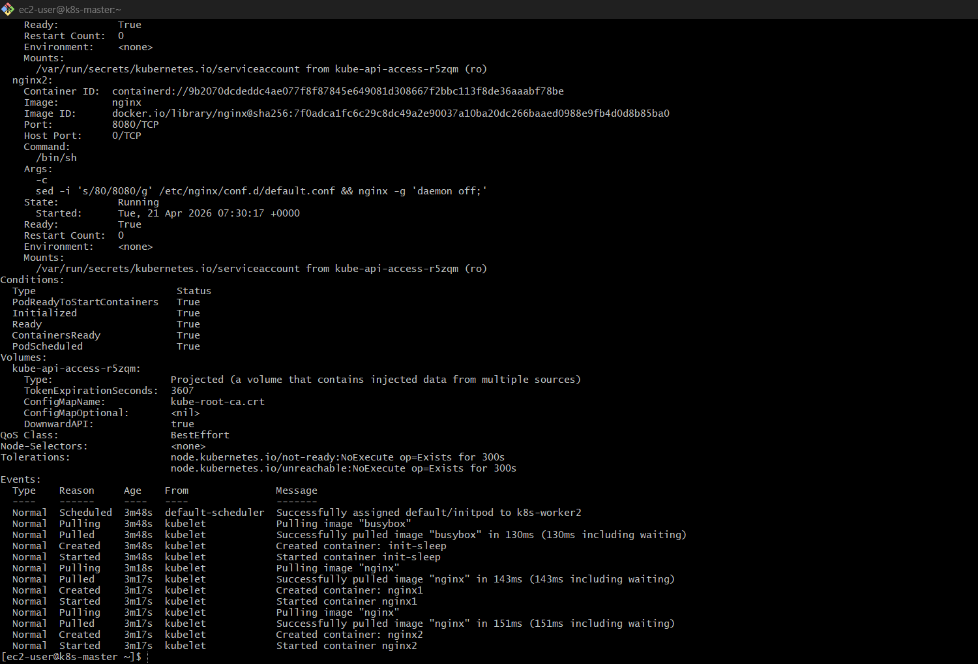
Look for:
Init Containers:
init-sleep:
State: Terminated
Reason: Completed
✅ This proves init container ran successfully

Step 5: Check Init Container Logs
kubectl logs initpod -c init-sleep

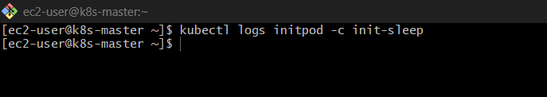
Output:
(empty — because sleep has no logs, but command ran)

Step 6: Verify Main Containers Running
kubectl get pods

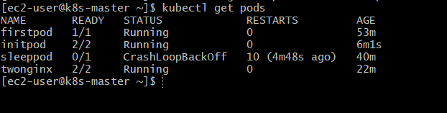
Should show:
initpod 2/2 Running

Bonus: Watch Live Execution
Run:
kubectl get pod initpod -w

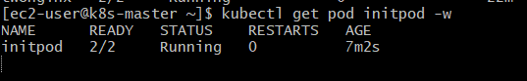

You’ll see:
Init:0/1 → Init:1/1 → Running

Common Mistakes
❌ Using same ports (your previous issue)
Already fixed here (80 + 8080)

❌ Init container never completes
Pod stuck in:
Init:0/1

Final Understanding
Init Container = setup phase
- DB migration
- Config download
- Delay (like your sleep)
Main containers = actual app

🔁 Quick Revision
- Add initContainers
- Deploy Pod
- Watch → Init → Running
- Verify → kubectl describe pod
- Logs → kubectl logs -c init-sleep

6) Run a Dry Run Command to Generate YAML Task: Use the kubectl run nginx --image=nginx --dry-run=client -o yaml command to generate a Pod YAML definition. Modify the generated YAML to suit specific requirements (e.g., labels or environment variables) and deploy it.

Step 1: Generate YAML using Dry Run
Run this:
kubectl run nginx --image=nginx --dry-run=client -o yaml

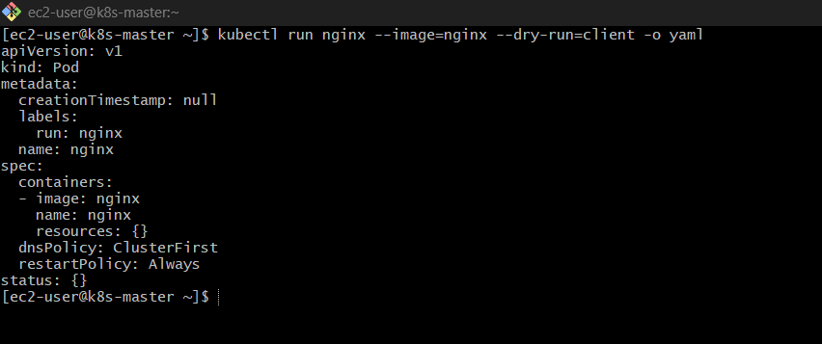
This will print YAML on screen (not create Pod)

Step 2: Save YAML to File
kubectl run nginx --image=nginx --dry-run=client -o yaml > nginx-pod.yaml

Now open file:
vi nginx-pod.yaml

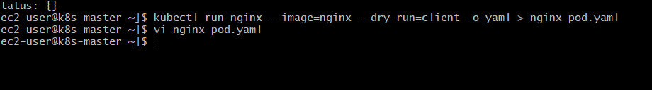

Step 3: Modify YAML (Add Labels + Env)
Update like this:
apiVersion: v1
kind: Pod
metadata:
name: nginx
labels:
app: mynginx
env: dev
spec:
containers:
- name: nginx
image: nginx
env:
- name: myname
value: "sabair"
- name: city
value: "Hyderabad"
ports:
- containerPort: 80

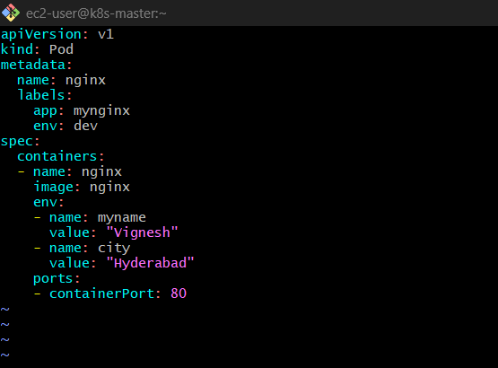
Save:
- ESC → :wq

Step 4: Deploy the Pod
kubectl apply -f nginx-pod.yaml

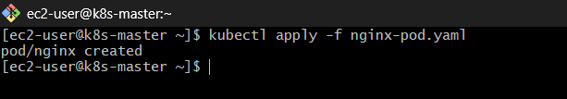

Step 5: Verify Pod
kubectl get pods
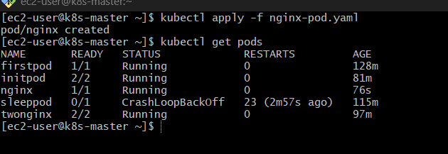
Expected:
nginx 1/1 Running

Step 6: Verify Labels
kubectl get pods --show-labels

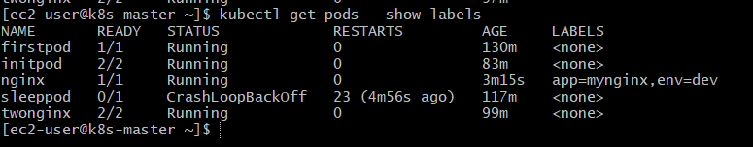
You should see:
app=mynginx,env=dev

Step 7: Verify Environment Variables
kubectl exec nginx – env

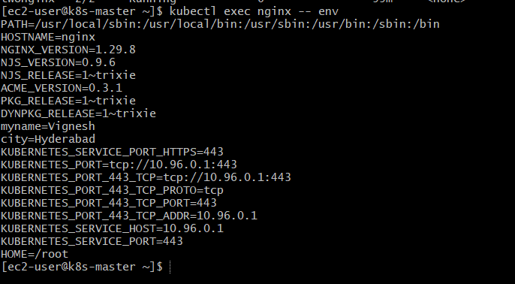

Look for:
myname=Vignesh
city=Hyderabad

Why Dry Run is Powerful
Instead of writing YAML manually:
- Generate → Modify → Apply

Common Mistakes
❌ Forgetting --dry-run=client
Pod gets created directly

❌ Not saving output
Use > to redirect to file

Final Flow
- Generate YAML
- Save to file
- Modify (labels/env)
- Apply
- Verify

7) Use kubectl apply vs kubectl create Task: Create a YAML file to define a Pod. First, deploy it using kubectl create -f <file_name>.yml and then modify the YAML (e.g., change the image version). Use kubectl apply to redeploy and verify the difference between both commands.

Step 1: Create YAML File
vi mypod.yaml

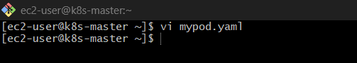

Paste this:
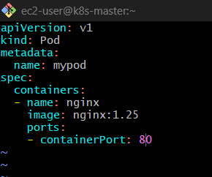
apiVersion: v1
kind: Pod
metadata:
name: mypod
spec:
containers:
- name: nginx
image: nginx:1.25
ports:
- containerPort: 80
Save (ESC → :wq)

Step 2: Create Pod using kubectl create
kubectl create -f mypod.yaml

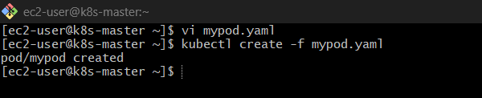
Output:
pod/mypod created

Step 3: Verify Pod
kubectl get pods
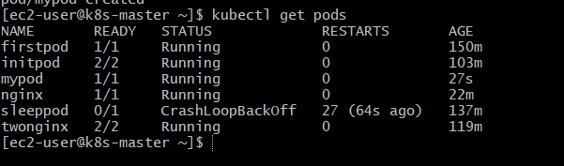

You’ll see:
mypod 1/1 Running

Step 4: Modify YAML (Change Image)
Open file again:
vi mypod.yaml

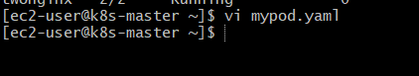
Change image:
image: nginx:latest
Save
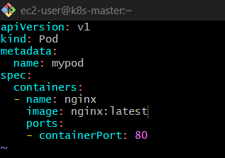

Step 5: Apply Changes using kubectl apply
kubectl apply -f mypod.yaml
Output:
pod/mypod configured

Step 6: Verify Change
kubectl describe pod mypod

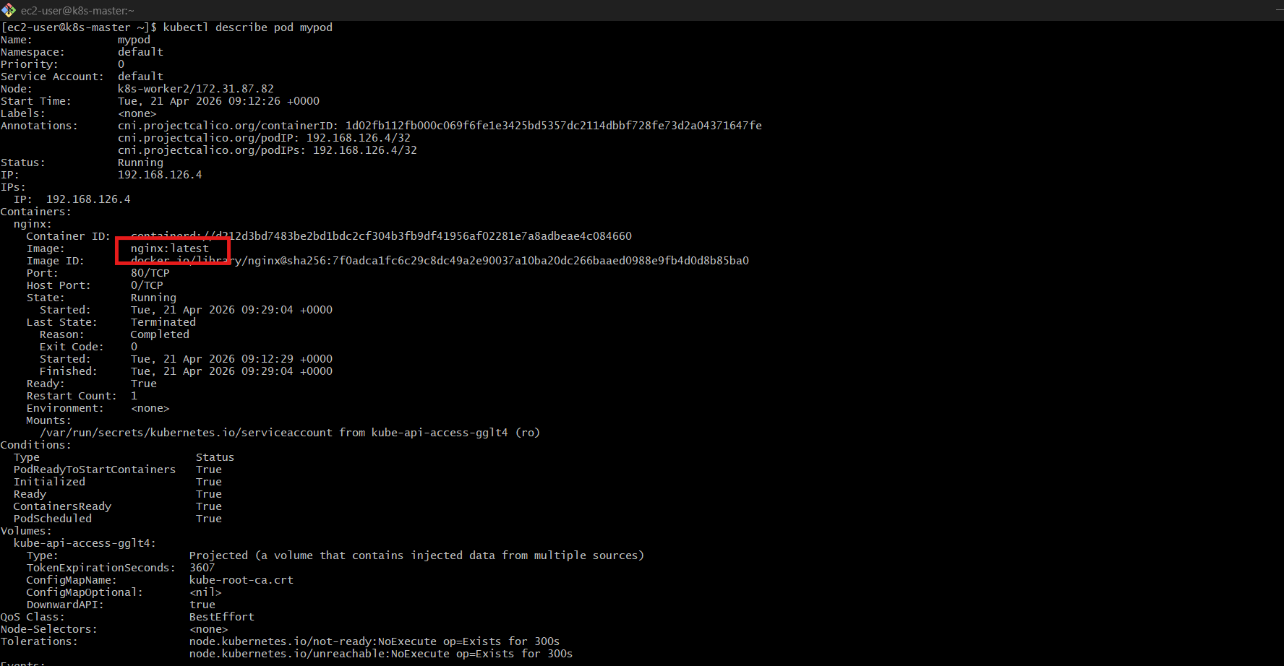
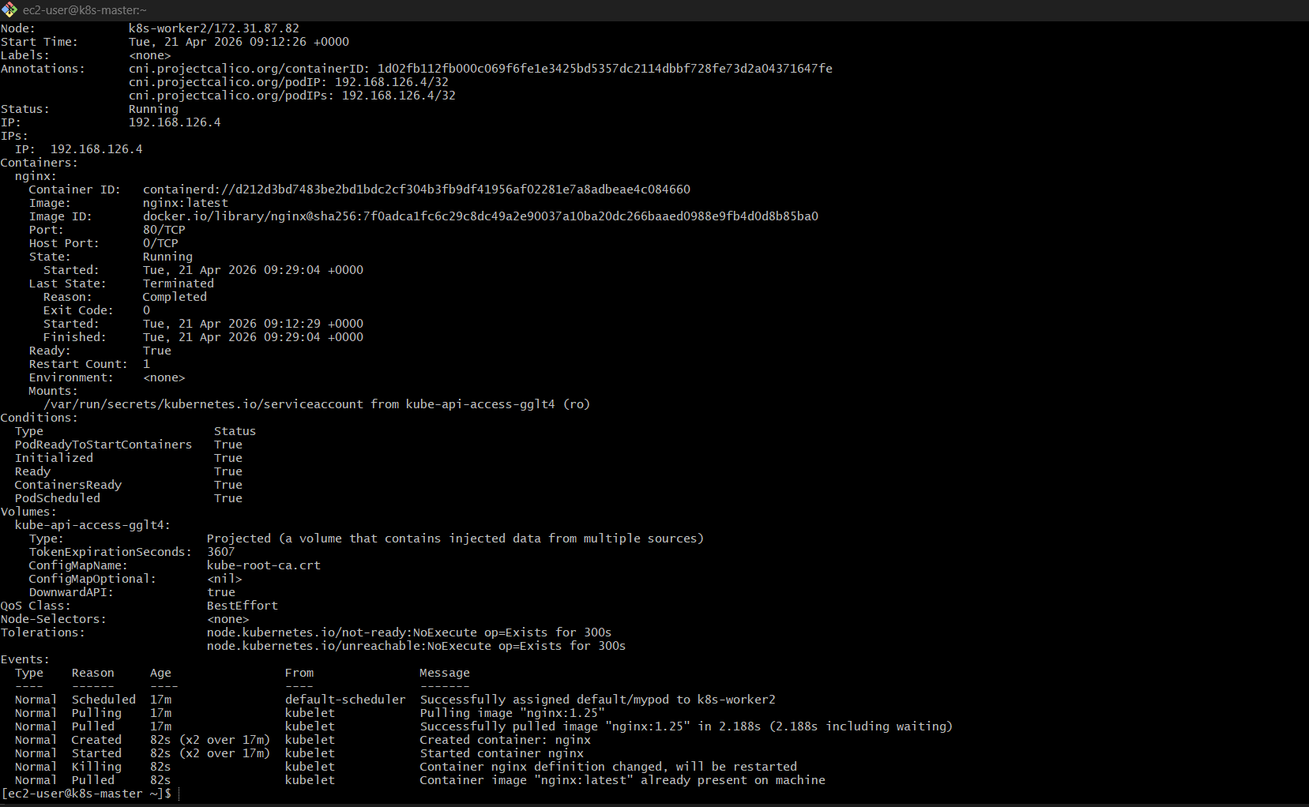
Check:
Image: nginx:latest

Bonus Check (Optional)
Run:
kubectl get pod mypod -o yaml | grep image
You’ll still see old image before delete
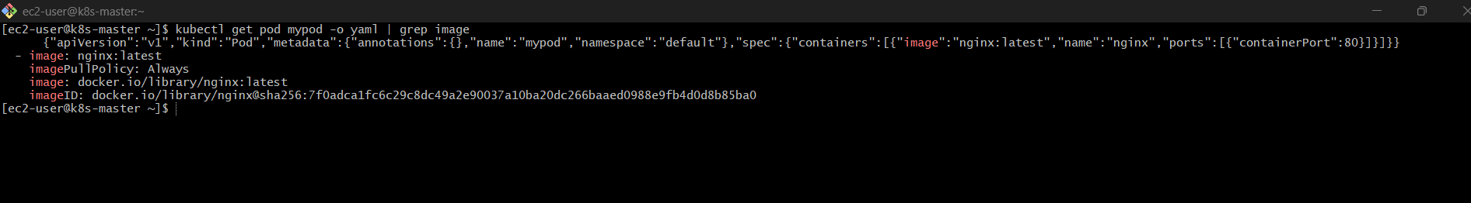

Now the REAL DIFFERENCE (IMPORTANT)
kubectl create
kubectl create -f mypod.yaml
Behavior:
- Creates resource only once
- ❌ If run again → error
Example:
Error: already exists
Use when:
- Creating new resource

kubectl apply
kubectl apply -f mypod.yaml
Behavior:
- Creates if not exists ✅
- Updates if exists ✅
- Tracks changes (declarative)
Use when:
- Updating config
- DevOps pipelines
- Real projects

Bonus Experiment (Try This)
Run again:
kubectl create -f mypod.yaml
You’ll get:
AlreadyExists error ❌

Now run:

kubectl apply -f mypod.yaml

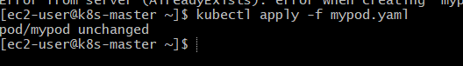
Works perfectly ✅

8) Edit an Existing Pod Configuration Task: Use kubectl edit pod <pod_name> to modify the running Pod's environment variables or image. After making the changes, verify if they took effect by checking the container logs or environment variables using kubectl exec.
Step 1: Check Existing Pod
kubectl get pods

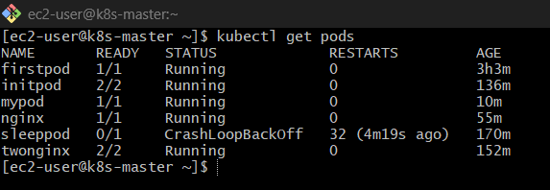
Make sure your pod (e.g., mypod) is Running

Step 2: Edit the Pod
kubectl edit pod mypod
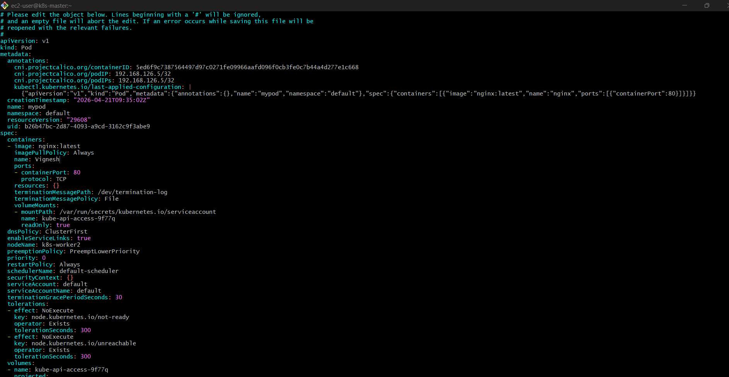
This opens YAML in editor

Step 3: Try Modifying (Two Cases)
🔹 Case A: Add Environment Variable ✅ (Allowed sometimes)
Find container section and add:
env:
- name: myname
value: "vignesh"

🔹 Case B: Change Image ❌
image: nginx:latest
This is where things get interesting…

Step 4: Save the File
- Press ESC
- Type :wq

What Happens Next?
❌ Most Common Output:
Error from server: pod updates may not change fields...
Means:
- Kubernetes rejected your changes

VERY IMPORTANT CONCEPT
Pods are IMMUTABLE
You CANNOT change:
- image ❌
- ports ❌
- container config ❌
You can change only limited fields like:
- metadata (labels, annotations)

Step 5: Verify (If Change Accepted)
If env change worked:
kubectl exec mypod – env

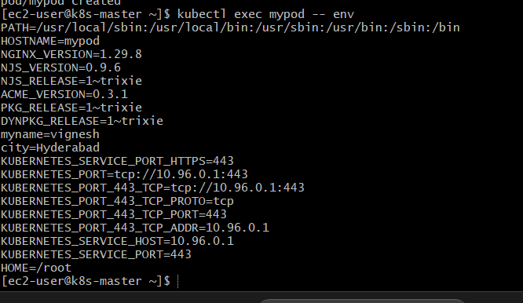
Look for:
myname=vignesh

Step 6: If Change NOT Applied (Most Real Case)
You must recreate Pod:
kubectl delete pod mypod
kubectl apply -f mypod.yaml

Alternative Trick (For Image Update)
Use:
kubectl set image pod/mypod nginx=nginx:latest
But even this:
- Often fails for Pods
- Works best with Deployment

Final Reality
kubectl edit pod is mostly used for:
- Quick debugging
- Metadata changes
NOT for:
- Real updates

🔁 Final Flow
- kubectl edit pod mypod
- Try change
- Save
- If rejected → recreate pod
- Verify using kubectl exec\

9) Expose a Pod Using a Service Task: Create a YAML file to expose your firstpod using a Service (ClusterIP). Ensure that your service is exposing the Pod on port 80 and verify it using kubectl get svc.

Step 1: Check Your Pod (VERY IMPORTANT)
kubectl get pods --show-labels

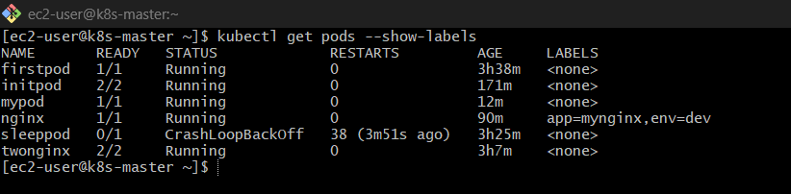
You should see something like:
firstpod 1/1 Running ... app=nginx

Service works using labels, so we must match them.

Step 2: Create Service YAML
vi firstpod-svc.yaml
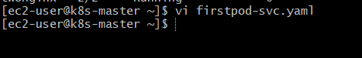
Paste this:
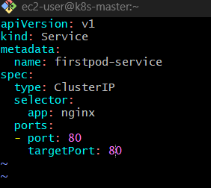

apiVersion: v1
kind: Service
metadata:
name: firstpod-service
spec:
type: ClusterIP
selector:
app: nginx
ports:
- port: 80
targetPort: 80
Save (ESC → :wq)

Concept
selector must match Pod label:
selector:
app: nginx
This connects:
Service → Pod

Step 3: Apply Service
kubectl apply -f firstpod-svc.yaml

Output:
service/firstpod-service created

Step 4: Verify Service
kubectl get svc

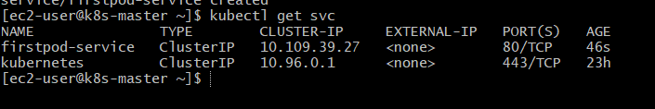
Example output:
NAME TYPE CLUSTER-IP PORT(S)
firstpod-service ClusterIP 10.96.x.x 80/TCP

Step 5: Verify Endpoints (IMPORTANT)
kubectl get endpoints

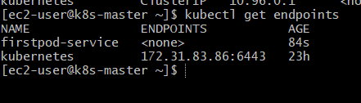
Should show:
firstpod-service <Pod-IP>:80
If EMPTY → selector mismatch ❌
Fix the Issue
🔹 Option 1: Add Label to Pod (Quick Fix)
kubectl label pod firstpod app=nginx
Now check:
kubectl get endpoints
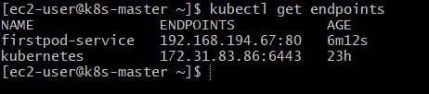
Expected:
firstpod-service <Pod-IP>:80

Step 6: Test Service (Inside Cluster)
Run:
kubectl exec -it firstpod -- /bin/sh
or
kubectl run testpod --image=busybox -it --rm – sh

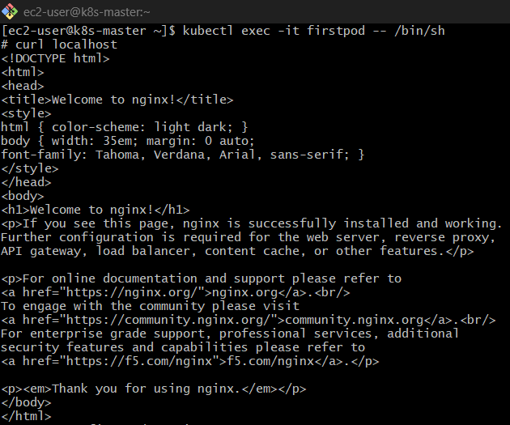

Inside pod:
wget -qO- firstpod-service

You should see:
NGINX Welcome Page
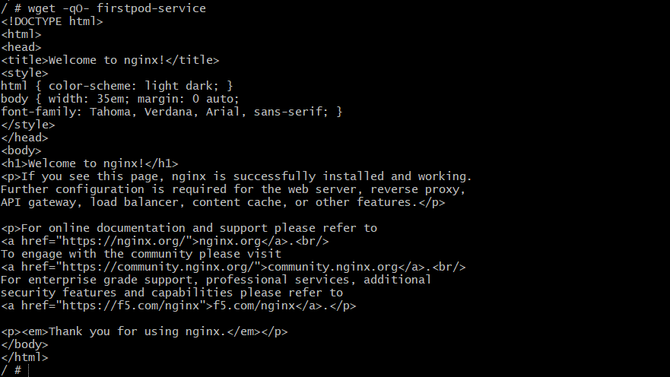

Common Errors
❌ Service not working
Check labels:
kubectl get pod firstpod --show-labels

❌ No endpoints
Fix selector to match labels

Final Flow
- Check pod labels
- Create Service YAML
- Apply service
- Verify using kubectl get svc
- Check endpoints
- Test using pod
10) Pod with Resource Limits and Requests Task: Add resource requests and limits to the containers in your YAML file. Specify CPU and memory requests/limits for both containers and deploy the Pod. Use kubectl describe pod to verify if the resource configurations are correctly applied.
Step 1: Create YAML with Resource Requests & Limits
vi resource-pod.yaml

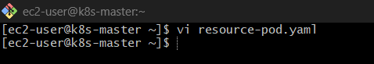
Paste this:
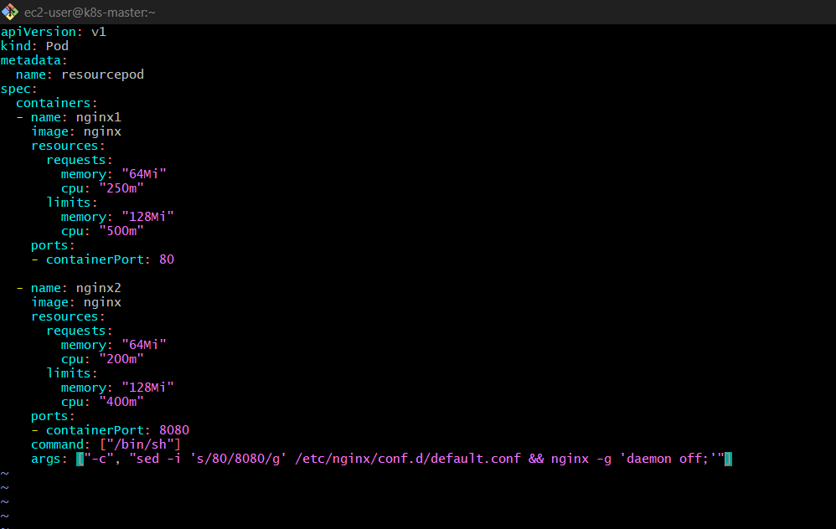
apiVersion: v1
kind: Pod
metadata:
name: resourcepod
spec:
containers:
- name: nginx1
image: nginx
resources:
requests:
memory: "64Mi"
cpu: "250m"
limits:
memory: "128Mi"
cpu: "500m"
ports:
- containerPort: 80
- name: nginx2
image: nginx
resources:
requests:
memory: "64Mi"
cpu: "200m"
limits:
memory: "128Mi"
cpu: "400m"
ports:
- containerPort: 8080
command: ["/bin/sh"]
args: ["-c", "sed -i 's/80/8080/g' /etc/nginx/conf.d/default.conf && nginx -g 'daemon off;'"]

Save (ESC → :wq)

Concept
Requests
- Minimum resources needed
- Scheduler uses this
Limits
- Maximum allowed
- Container cannot exceed

Step 2: Deploy Pod
kubectl apply -f resource-pod.yaml

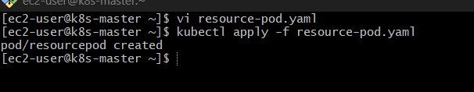

Step 3: Verify Pod
kubectl get pods

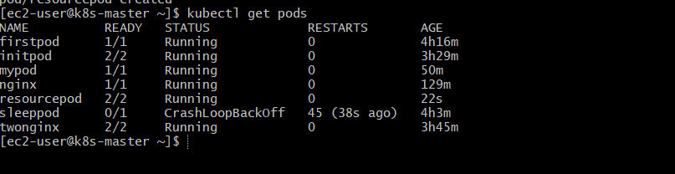
Wait until:
resourcepod 2/2 Running

Step 4: Verify Resources (MAIN TASK)
kubectl describe pod resourcepod

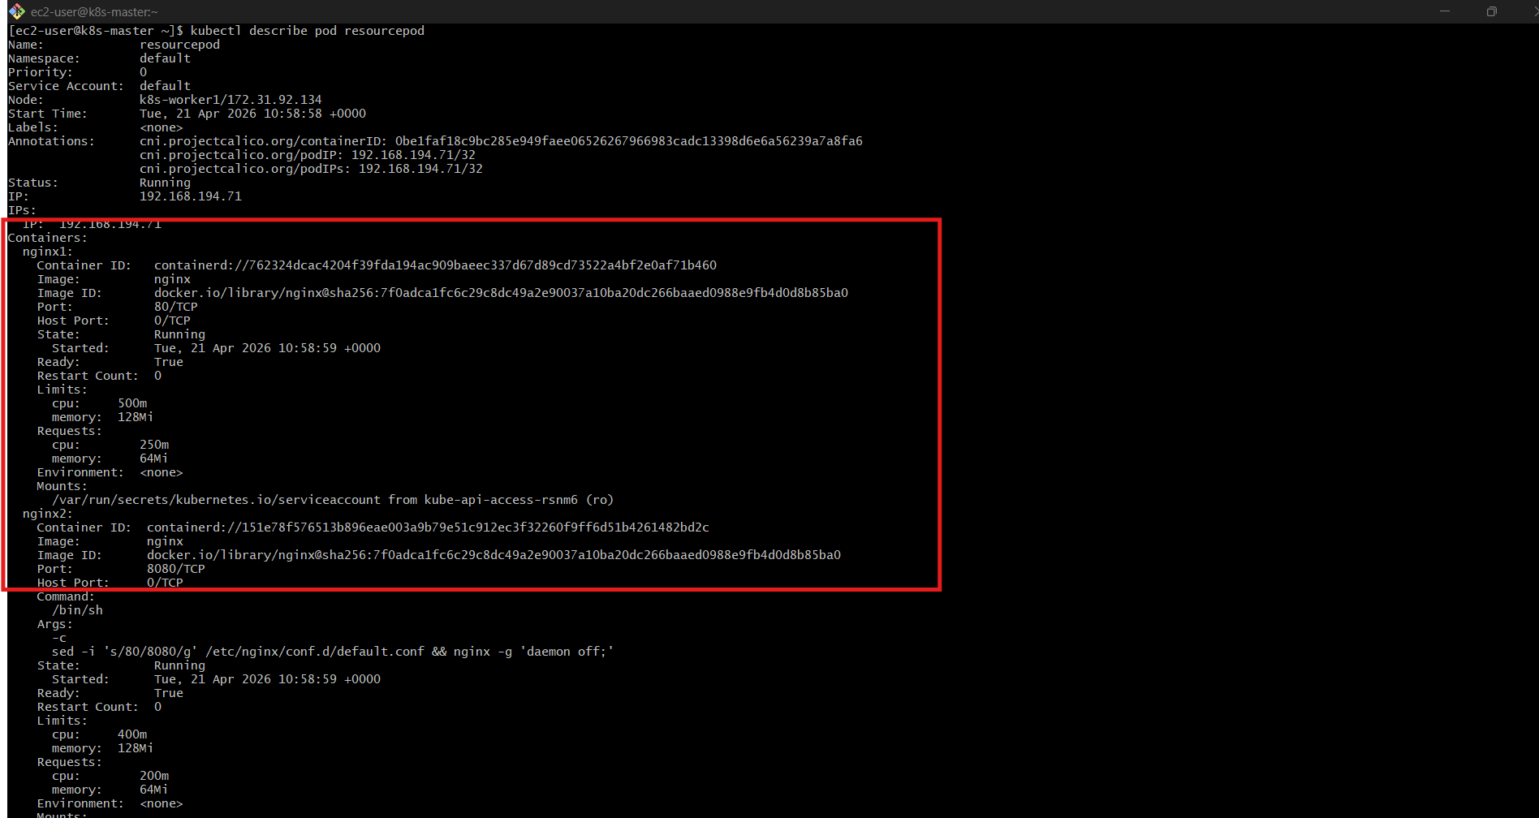

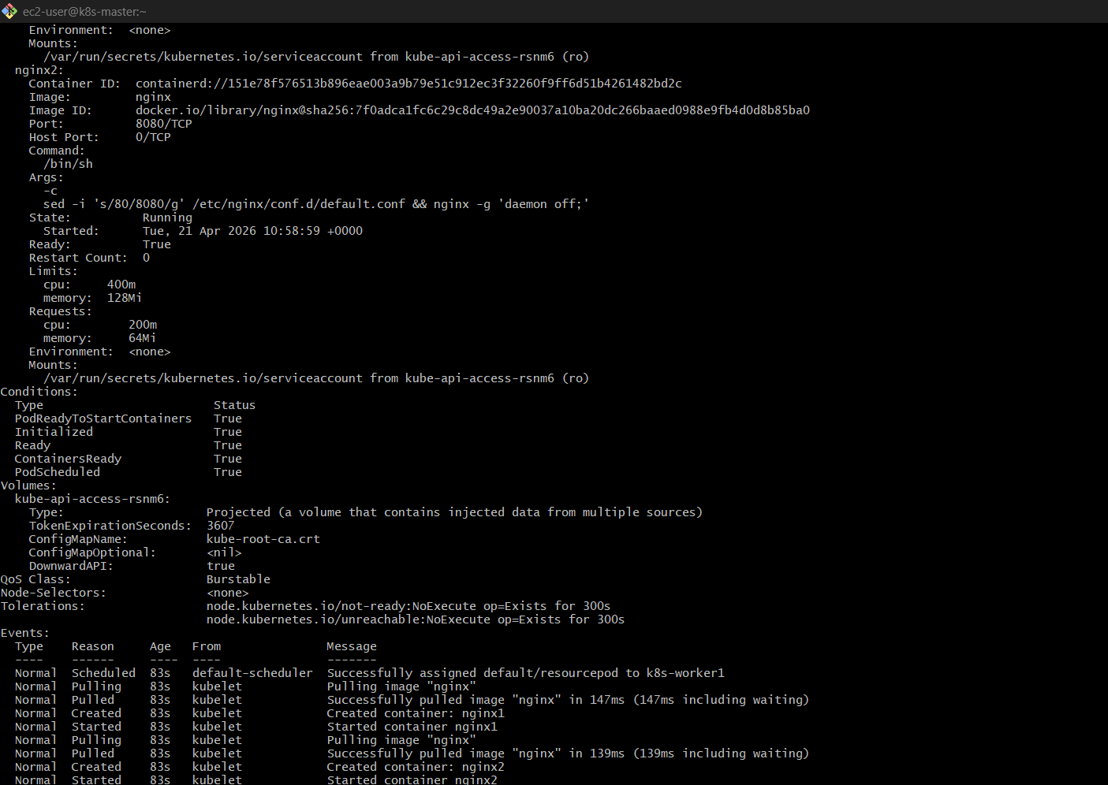

Look for this section:
Containers:
nginx1:
Limits:
cpu: 500m
memory: 128Mi
Requests:
cpu: 250m
memory: 64Mi
nginx2:
Limits:
cpu: 400m
memory: 128Mi
Requests:
cpu: 200m
memory: 64Mi
✅ This confirms resources are applied

Step 5: (Optional Advanced Check)
kubectl top pod resourcepod

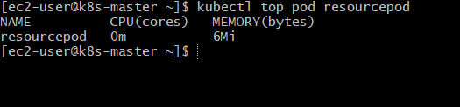
Shows real-time usage (if metrics-server installed)

Common Errors
❌ Pod Pending
Reason:
Insufficient CPU / Memory
Fix:
- Reduce requests
- Or add more nodes

❌ CrashLoopBackOff
If memory too low

Final Flow
- Add resources: in YAML
- Apply YAML
- Check → kubectl get pods
- Verify → kubectl describe pod

